District 14 January 2018 Minutes – January 3, 2018
John H, DCM | Chad U, Secretary | Malcomb B, Treasurer | Mike C, CPC-PI
Debbie E, Alt DCM | Michelle M,  Alt Secretary | Jen McM,  Alt Treasurer | Linda B,  Alt CPC-PI
Corey C, Corrections | Shelley S, Grapevine | Travis K, Literature | Dani M, Treatment
District 14 meetings are the first WED of each month, 6:30 pm, upstairs @
Harmony House Café, 47 N. Main Street, Washington.
District 14 Events available at: http://www.district14.info/d14events.htm
District 14 GSR Handbook PDF available at: http://www.district14.info
Send group contributions to: District 14 Treasurer, 104 River Road, Rices Landing, PA 15357

Groups Represented [14]
AA Literature on Main, Camel Meeting, Canonsburg As Bill Sees It, Canonsburg Group, Canonsburg Open Discussion, Good Orderly Direction, Hill 12 & 12, Made It Til Noon, McMurray Women’s As Bill Sees It, Primary Purpose AA, Renewal Group, Sunday Morning Early Birds, Thursday Night Trudgers (TNT), Wednesday Night Daily Reflections

Officers/Coordinators Present [10]
DCM, Treasurer, Secretary, Alt Secretary, Corrections Coordinator, CPC-PI Coordinator, Alt CPC-PI, Grapevine Coordinator, Literature Coordinator.

Interested Parties Present [3]

Welcome, Call to Order, & Open Meeting with Serenity Prayer (DCM) at 6:31 pm

Roll-Call (Alt Sec)

Reading of Concept X from AA Service Manual (Jen McM)

Minutes
- December 2017 Minutes presented for approval, with amendment that we did not vote on the Picnic in December, just to take the idea back to our groups for voting this month.
  - MOTION (to accept Dec minutes as amended): Malcomb B; SECOND: Debbie E. VOTE: Unanimous Yea.

Pass the Basket (district 7th Tradition)

GSR Report Highlights (Events/News/Support)
(If you are a GSR and not able to make the district meeting, make sure you give your report to your alternate to present, or email it to the Secretary.)
- See Groups Represented above.
- See District Events page at http://www.district14.info/d14events.htm
  - Second SUN of every month; Prosperity Potluck
    - Starts at 6 pm.
  - SUN, 1/21; Area 60 1st Quarterly Meeting
    - Penn Hills, 699 Rodi Road. Registration @ 8:30 am; workshop @ 9; meeting @1015.

Officer & Coordinator Reports
(If you are an officer or coordinator and not able to make the district meeting, make sure you give your report to your alternate or someone else to present, or email it to the Secretary.)

DCM
- People have mentioned a need for a daily morning meeting from 6-7 am, M-F; if interested, see John H.

Alt DCM
- Notes from Area 60 4Q2017 meeting, especially the discussion of “anonymity, spirituality, & social media.”
- Pre-Conference Assembly Weekend (PCAW) is March 23-25. She has registration forms. (See also below.)
  - Thomas S mentioned group conscience items, like General Service Conference agenda items, are discussed.
- Suggested district 14 groups check their meeting in the Area 60 website meeting finder to make sure the info is correct. https://www.wpaarea60.org/meetings/

Corrections
- From Dani’s email: SCI Greene is celebrating their 22nd anniversary this month. We have traditionally invited a guest speaker, and our volunteers will be there to help celebrate with coffee and a cake!
- Set-up with the Area 59 database in Philly to connect with people leaving facilities there that are coming to the Pittsburgh, PA area.
- TO DO (GSRs): Please take to your groups!!! We need more men volunteers at the Washington County Jail (WCCF). Volunteers need 2 years off paper, two years sober. Meeting average about 10 guys.
  - We always need more volunteers for the state facilities, too.

Treasurer
- See revised Treasurer’s Report sent 1/3.
  - TO DO (Treasurer): Will update budget lines to match 2018 budget lines (from December 2107 Minutes) for next report.
- 2018 Budget is in last month’s minutes on pages 4-5.
- We have surplus funds of $1848.88 from 2017.

Literature
  - Quickly, stopping by on lunch break from work…
  - Literature Report emailed 12/30.
  - Sold 42 Meetings in a Pocket.
  - We are close to an order; get your orders in now.
  - Will only be keeping around 30 Meeting Lists and District 14 Newcomer brochures on-hand at a time; if you want more, let him know ahead of time.
  - Have not received yellow cards yet. Said they would take 3-4 weeks.

Treatment (absent; report by email)
  - Treatment Report & Sign-up Sheet forwarded by email 1/3.
    - Gateway and Greenbriar coverage for February needed!
  - Bridging the Gap: Good news also pertaining to Fayette. We have SUCCESSFULLY set up a contact from the Area 59 data base in Philly to call and meet with an AA being released and going home on the 8th. I will follow up on it this weekend! Hopefully, it will be another Bridging the Gap success! Thanks for being you! xxox

Grapevine (absent)

CPC/PI
- Ordered CPC/PI literature for Washington and Greene County; distributed it before holidays.
- Work schedule makes it difficult to deliver lit; needs assistance getting around.
  - TO DO (CPC/PI): Will talk to John H offline for other ways to do CPC/PI.

Alt CPC/PI (no report)

Old Business

District Picnic (VOTE)
- Good leadership last year; good stewardship of budget funds.
- $300 budget this year.
- Consensus of homegroups is for it.
- No date yet: Thomas & Shelley will go to figure out what days are available.
- MOTION (to use part of the 2017 budget surplus and District Event Fund to have a picnic in 2018 with a $300 budget). Thomas S; SECOND: Kaitlin H. VOTE: Unanimous Yea.

Description on “How to Use the District 14 Meeting in a Pocket” (John H)
- John said he “overstepped his advocacy” in taking on writing up the “blurb” for how to use the MiaP.
  - This is to be a short explanation of how it can be used, in early/mid/late sobriety, as a sponsor/sponsee, what sort of tool is it, etc.
  - He will assist anyone who steps up.

Placing the District 14 Meeting in a Pocket PDF/PUB files on the district website (Chad U)
- Note that parts of it are not AA conference-approved, though we can print what we want (Debbie E).
  - John H suggested updating it.
  - Ed M said people he’s talked to love it and use it.
- Malcomb suggested tabling until all the inventory/assets are sold (about 1000 copies).
  - Will S said that when it’s helping the next person stay sober, money shouldn’t be an issue.
  - Matt M said that the meetings that buy it will continue to buy it even if it is on the website.
  - Patrick A remarked it’s handy if there are no copies on-hand and you have access to a computer.
- MOTION: Put the PDF and PUB files of the MiaP on the District 14 website.
  - VOTE: 19 Yea, 2 Nay, 2 Abstention.
    - MINORITY OPINION: n/a
    - CALL FOR RE-VOTE? n/a
    - The YEAs have it.
- TO DO (Secretary): Place files on website.

Contract for district meeting rent (John H)
- John H recused himself as DCM for speaking for the district as he’d be representing Harmony Life Center (HLC).
  - Thomas S raised an objection to this; Keeshia M suggested John recuse himself altogether, from both sides, to avoid conflicts of interest.
    - John H agrees; suggest Reverend Tom Bellhy to represent HLC.
  - Matt M will represent district 14.
  - Malcomb asked who the rent check should be made out to?
    - Matt M pointed out that as we discussed last month, it’s HLC.
- CONSENSUS: Have Matt M negotiate with the Reverend Bellhy for district meeting rent contract.

New Business

Should our email addresses on district communications be placed in the BBC line to keep anonymity, or left in the clear? (Chad U)
- CONSENSUS: It is fine the way it is (GSRs in To, Officers/Coordinators in CC, and Interested Parties in BCC).

Jen McM stepped up as Alt Treasurer (Malcomb B)
- CONSENSUS: Welcome, Jen!

Increasing the Bridging the Gap (BtG) Budget (John H)
- John H suggested increasing the budget line for BtG by $750, to allow a representative (Dani M?) to attend the second BtG conference in CO this fall. This will help us learn best practices, and keep a successful program going. Everyone’s doing a great job with it. Our biggest losses come between leaving treatment and getting to the rooms of AA.
  - Chad U suggested not changing the budget we just voted on after two months of discussion, but to use the 2017 budget surplus instead.
  - Some folks in the room agreed this would be a legitimate use of surplus funds.
  - Will $750 cover airfare, registration, hotel, food? (Jen McM)
    - Malcomb suggested raising that amount to $1000.
  - Steve H suggested that if the groups buy more MiaPs, that would improve our bottom line.
  - Debbie E said that everything like this should be a shared expense, but when money gets involved, people get contentious.
    - John H said that asking with a price tag attached might be a bad idea.
    - Matt M suggested that we keep “sending Dani to this conference,” “sending someone to this conference,” and “what kinds of things we can do” as separate issues, and that the costs of these things, the amount of money involved, is important.
  - Shawn G asked if Dani has the intention of standing for another term as Treatment Coordinator/Bridging the Gap chair. If not, why send her a month or two before she steps down?
    - Patrick A thinks that as a person, Dani M would bring back great information whether or not she’d continue to serve as a Coordinator.
    - Kaitlin said that we need to make sure Dani is interested; she herself wold not be comfortable sending someone new to the conference.
- TO DO (GSRs): Take back to group: is using some of the 2017 budget surplus to send a representative to the BtG conference in Colorado this fall a good use of district funds?
- TO DO (GSRs): The DCM also would like to hear the home groups’ ideas on how the district can be of more service to them. What other ways can we assist? How can we be more effective? The purpose of a district is to do things that any single group would find burdensome to do alone (treatment, corrections, save money on literature with larger orders, etc.).

What do you want to see at district meetings? (all)
[NOTE: There is mild editing/reorganization of the topics below to logically connect issues from a wide-ranging discussion into a sense of flow.]
- BUDGET: Ben P brought up that the district coordinators are budgeted money to be used, and it’s not being used… that’s why we have a budget surplus. It’s an ongoing problem for the past several years in district 14… money not being used fully.
  - John H said that he didn’t use all his gas allowance.
  - Several coordinators mentioned they were trying to be good stewards of the money.
  - Thomas S mentioned that Shelley and he brought the picnic in under budget due to lots of contributions, personal and from other individual AAs and groups.
- EVENTS: Basic suggestions include a Day of Sharing, site bid for an area quarterly meeting, GSR or AA workshops (sponsorship, GSR, meeting etiquette, steps/traditions/concepts, BtG, etc.)
  - Steve H suggested we look into a Day of Sharing; we’d get support and participation from the area.
  - Chad U and Debbie E mentioned that the DCM of district 7 was looking to talk to John H at last area meeting to discuss participation in the fall districts 7/11/14 Day of Sharing.
  - Could we do just a district-level Day of Sharing?
  - Shawn G suggested a district-level (Washington & Greene Counties) metropolitan meeting – like the one Mike C, Debbie E, and Chad U attended – that was put on by the Pittsburgh Central Office? A meeting for public outreach to local professionals (CPC/PI)?
    - Linda B likes this idea. She offered some negative opinions on suboxone clinics and other recovery without the 12 Steps. She mentioned that the message is not getting out that AA is worldwide tested for decades recovery solution… and it’s free – “do it for fun and for free.”
    - John H said that while we are bound by anonymity, are we being too concealed? People understand what a methadone/suboxone clinic is, or what rehab is, but do they understand what AA is?
    - Chad and Debbie both agreed that that is what a metro meeting would be for… public information.
  - Matt M remarked that the basic problem for district 14 is where to have these events? What space, what day, how much will it cost?
  - Could rehabs be invited to these events? Jen McM commented that doing so would help “bridge the gap” between treatment and the meetings/people in the district?
    - Malcomb mentioned he wanted/wants to save the world with the message of AA, but over the years he’s learned that this program is for people what want it not people who need it.
    - Chad mentioned that the state convention has given free registration for folks from rehabs for the past two years. The first year, it was just a thing, but last year, some of the rehabs had made going to the convention a reward for those clients who were doing what was asked of them.
    - Ed M said that he found it difficult to believe that the rehabs don’t know about AA; Matt M responded that in his recent 28 days in rehab, he went to an outside AA meeting once.
    - Maybe directing them would help?
    - Patrick A said that when he worked for Greenbriar, the techs don’t use much discretion in picking fellowships to take clients to. Also, the client population is more focused on problems other than alcohol. Making the distinction might be worthwhile.
      - Also, he’s helped get the taped AA PSAs on the college radio station, but WJPA wanted text to read, and the local personalities were uncomfortable reading it. He’s also done a show on recovery that was very respectful. Maybe PI could be more pro-active? Perhaps a recovery talk-show on the air?
    - Kaitlin was taught, when she picked AA as her fellowship (despite having problems other than alcohol) to respect the fellowship… but when you’re giving a lead, if you’re not honest about other problems like drugs, you’re doing the listeners a disservice.
- PROBLEMS OTHER THAN ALCOHOL: Chad U suggested that we as a district have something special and unique to say about the relationship between drugs and alcohol. We have been ground-zero for the opioid epidemic for years, many of our members and trusted servants have multiple issues/addictions, many of our members and trusted servants have been active in mutliple fellowships, and that Washington & Greene Counties have a large/disproportionate number of treatment facilities, halfway houses, three-quarter-way houses, and other sober living housing.
  - Matt M suggested we need to start crossing aisles.
  - Jen McM mentioned attending a Big Book meeting with Chad U at the Dry Peoples’ Club of Akron, OH. While it was an AA meeting, the chair read a paragraph that sounded something like, “We are an AA meeting, and we talk about alcoholism here, but we realize people in this town have more problems than just booze, and a lot of people are dying out there. We want you to know you’re welcome to be here.”
  - Several people remarked that “pure” alcoholics are rare these days; some even noted that neither Bill W nor Doctor Bob were “pure” alcoholics.
  - Thomas S noted that almost all 12 Step fellowships “started in” AA.
  - Ed M agreed 100%, with one reservation. Bill W addressed it in a paragraph in his writings, that we should exclude the exclusively addicted, but not the cross-addicted.
    - Chad U pointed out that this is an article Bill W wrote for the February 1958 Grapevine (this article was modified into AA pamphlet P-35, Problems other than alcohol)
      - https://www.aa.org/assets/en_US/P-35_ProOtherThanAlcohol.pdf
    - Chad also offered that exactly this is how new AA pamphlets get written. We see a need or opportunity on the group/district level, and write something. If others find it useful, we can take it to area or our delegate directly. If he/she thinks it’s useful, he/she can take it to the General Service Conference… and it could be a new piece of AA literature. And, if not, there’s plenty of useful recovery literature that’s not conference-approved.
  - John H noted that the interest level of the meeting was high, and agreed that we definitely do have something to say here about problems other than alcohol, from the AA/District 14 perspective.
  - CONSENSUS: The district will continue to explore this idea, that we have something valuable to say about this topic. GSRs should talk to their groups about what they think.

MOTION (to close): Malcomb B; SECOND: Thomas S. VOTE: Unanimous Yea.

Close with Responsibility Statement (at 8:11 pm)

NEXT MEETING: February 7, 2018
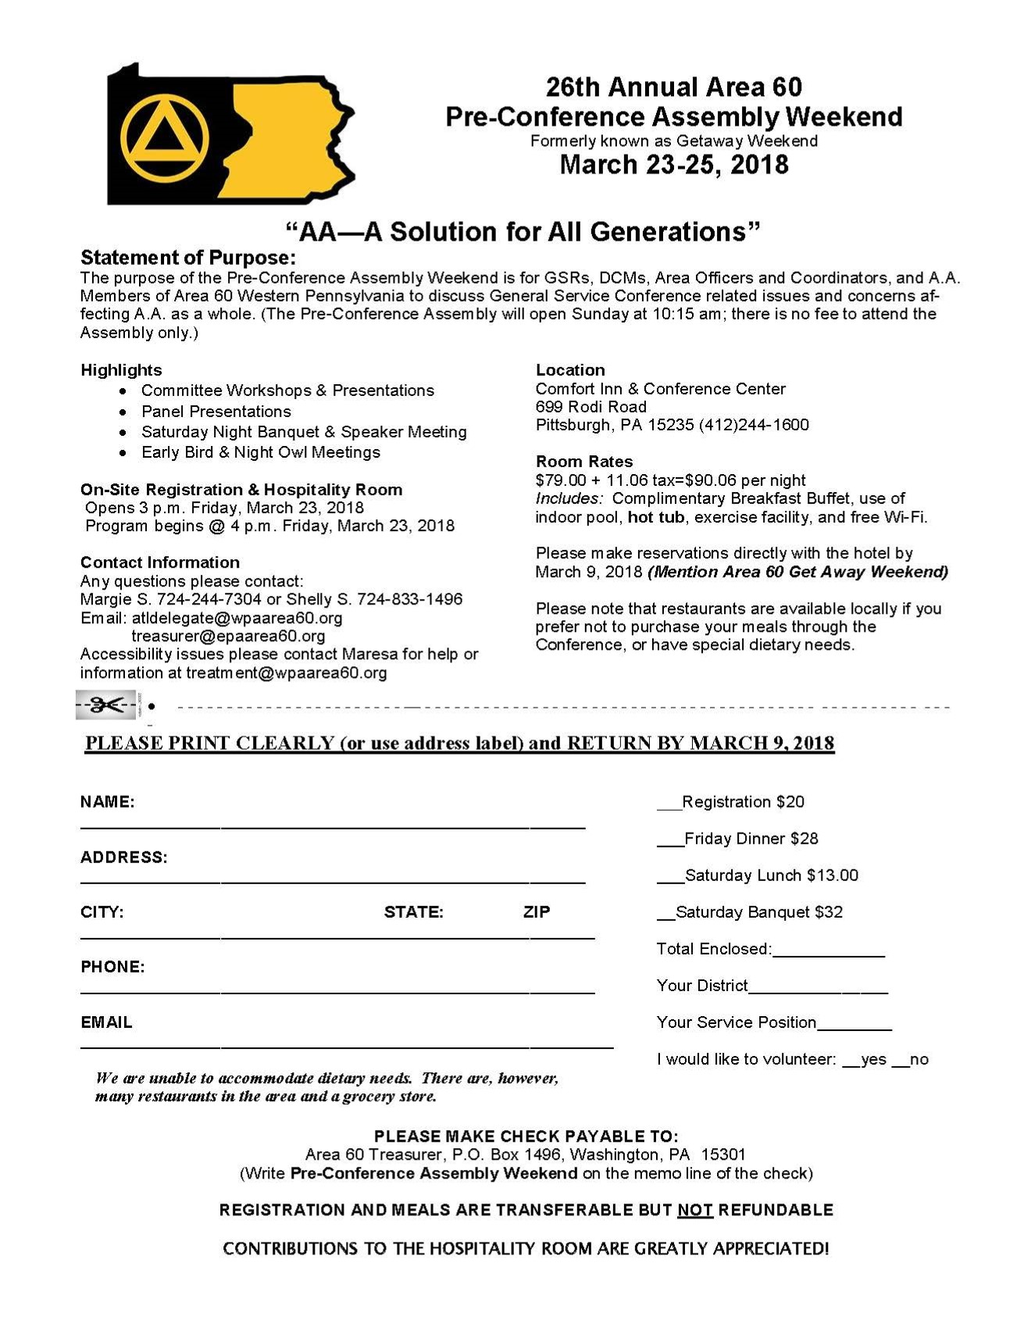
2018 | Greenbrier  SUN 11 AM & THURS 7 PM | Gateway  MON 7 PM & THURS 11 AM
JANUARY | AS BILL SEES IT  MICHELLE 4128972673 | RENEWAL  BILL C. 724-255-2341 DEBBIE E.4129690126
FEBRUARY | OPEN | OPEN
MARCH | RENEWAL  BILL C. 724-255-2341 DEBBIE E.4129690126 | OPEN
APRIL | OPEN | OPEN
MAY | OPEN | CROSSROADS  MICHELLE Y. 7248843941
JUNE | MADE IT TIL NOON  LINDA B. 724-592-5402 | OPEN
JULY | OPEN | OPEN
AUGUST | CANONSBURG TUESDAY NIGHT  BOB V. 412-897-7927 | OPEN  .
SEPTEMBER | OPEN | OPEN
OCTOBER | OPEN | OPEN
NOVEMBER | HILL CHURCH  DANI M. 724-709-3836 | OPEN
DECEMBER | CANONSBURG TUESDAY NIGHT  BOB V. 412-897-7927 | OPEN

Hello, fellows! “WE” NEED YOUR HAND OF AA TO REACH OUT!
Do your home group members want the privilege of putting your group’s special name in one of the above open spots? “WE” like helping others gain sobriety while staying sober ourselves. Do “WE” want to give away what was so freely given to us? Of course, we do! This fantastic opportunity is a rewarding privilege for members of Alcoholics Anonymous.! Sign up now to give it away! Call or email me to save your spot. Thanks in advance, and as always….
Service with a Smile,
Dani
danimikula@live.com or 724.709.3836

